METRO TICKET BOOKING SYSTEM
5 Project Development Phase

5.1 Development Environment
Modules Used:
• Custom Application (Metro Ticket Booking)
• Custom Tables
• Business Rules
• Script Includes
• Flow Designer
• Service Portal
• Access Controls (ACLs)
• Reports and Dashboards

5.2 Custom Table Creation and Configuration
Metro Passenger :
Field Label | Data Type | Description
Passenger Name | String | Passenger full name
Email | Email | Passenger email address
Mobile Number | String | Contact number
Passenger Type | Choice | Regular / Student
Active | True/False | Active passenger status
User | Reference → User | Linked ServiceNow user
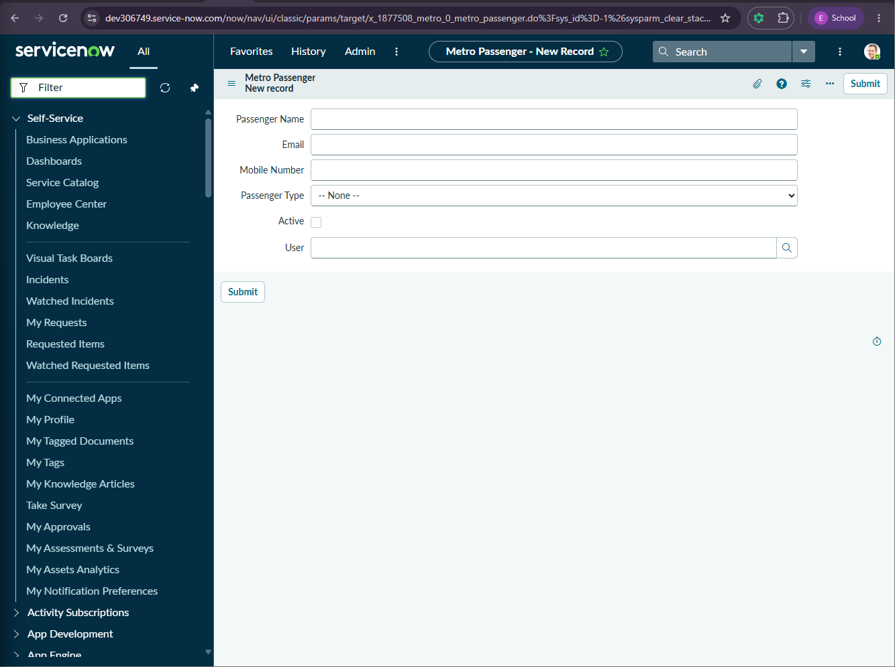
Metro Booking :
Field Label | Data Type | Description
Booking Number | Auto Number | Unique booking ID
Passenger | Reference → Passenger | Passenger making booking
Source Station | Reference → Station | Starting station
Destination Station | Reference → Station | Ending station
Journey Date | Date | Travel date
Passenger Count | Integer | Number of passengers
Fare Amount | Currency | Calculated fare
Payment Status | Choice | Pending / Paid / Failed
Booking Status | Choice | Booked / Cancelled / Completed

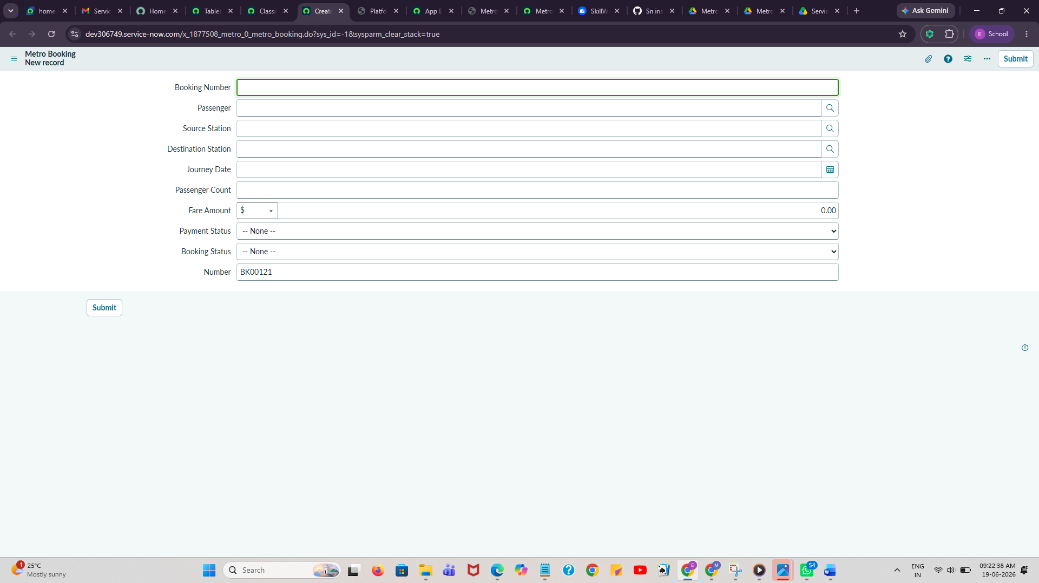

Metro Student Profile :
Field Label | Data Type | Description
Student Name | String | Student name
User | Reference → User | Linked ServiceNow user
College Name | String | College name
Student ID Number | String | College ID
Department | String | Student department
Year | Choice | Academic year
Verification Status | Choice | Pending / Approved / Rejected
Verified By | Reference → User | Verifying administrator
Verified Date | Date/Time | Verification date

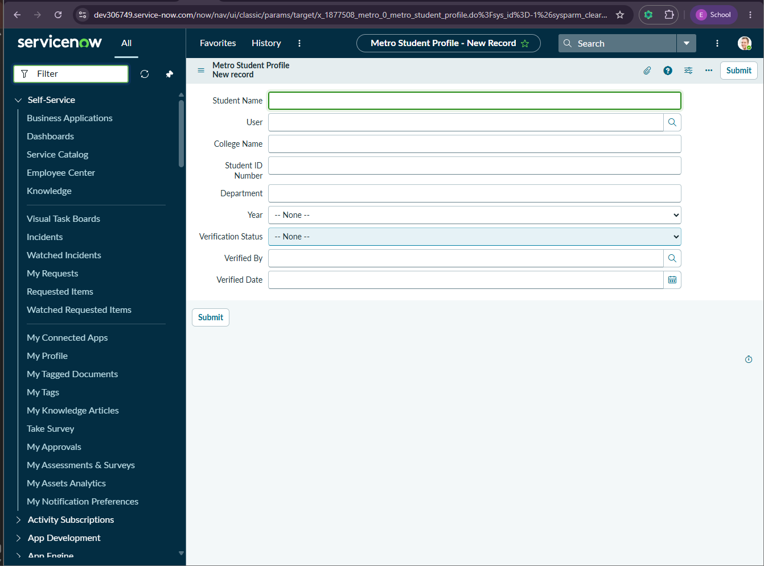

Metro Student Pass :
Field Label | Data Type | Description
Pass Number | Auto Number | Unique pass number
Student | Reference → Student Profile | Student
Pass Type | Choice | Weekly / Monthly
Source Station | Reference → Station | Starting station
Destination Station | Reference → Station | Ending station
Valid From | Date | Pass start date
Valid Until | Date | Pass expiry date
Pass Amount | Currency | Pass amount
Payment Status | Choice | Pending / Paid
Pass Status | Choice | Active / Expired
QR Ticket | Reference → QR Ticket | Linked QR ticket

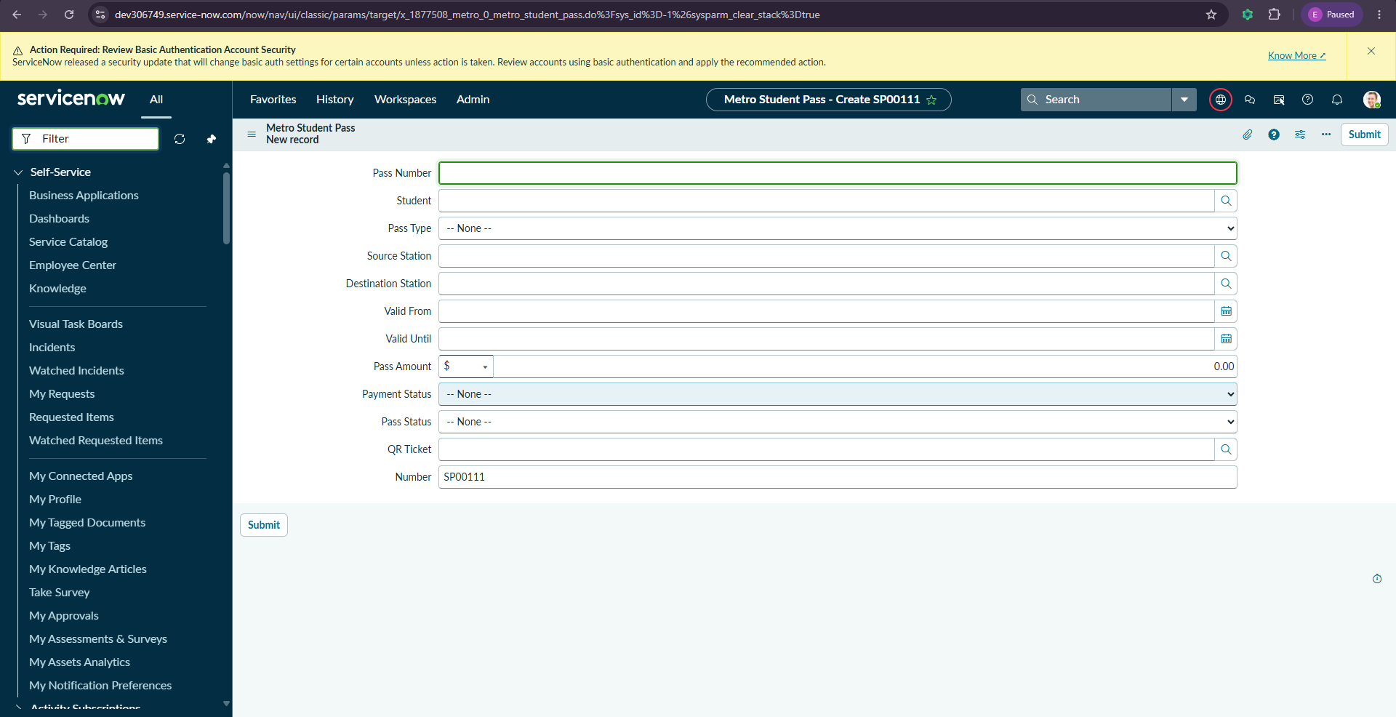
Metro Payment :
Field Label | Data Type | Description
Payment ID | Auto Number | Unique payment identifier
Booking | Reference → Booking | Linked booking
Student Pass | Reference → Student Pass | Linked pass
Payment Method | Choice | UPI / Card / Cash
Amount | Currency | Payment amount
Transaction Status | Choice | Success / Failed
Transaction Reference | String | Transaction reference number
Payment Time | Date/Time | Payment timestamp

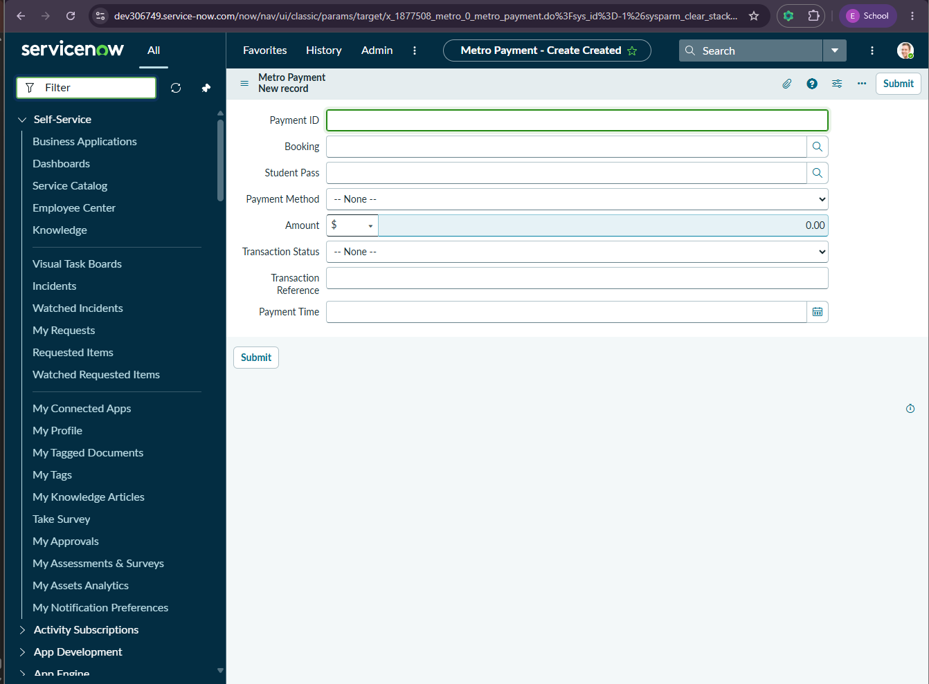
Metro QR Ticket :
Field Label | Data Type | Description
QR Ticket ID | Auto Number | Ticket identifier
Booking | Reference → Booking | Linked booking
Student Pass | Reference → Student Pass | Linked pass
QR Code Value | String | QR code value
Valid From | Date | Ticket start validity
Valid Until | Date | Ticket expiry date
Entry Status | Choice | Allowed / Pending
Exit Status | Choice | Allowed / Pending
Ticket Status | Choice | Active / Used / Expired

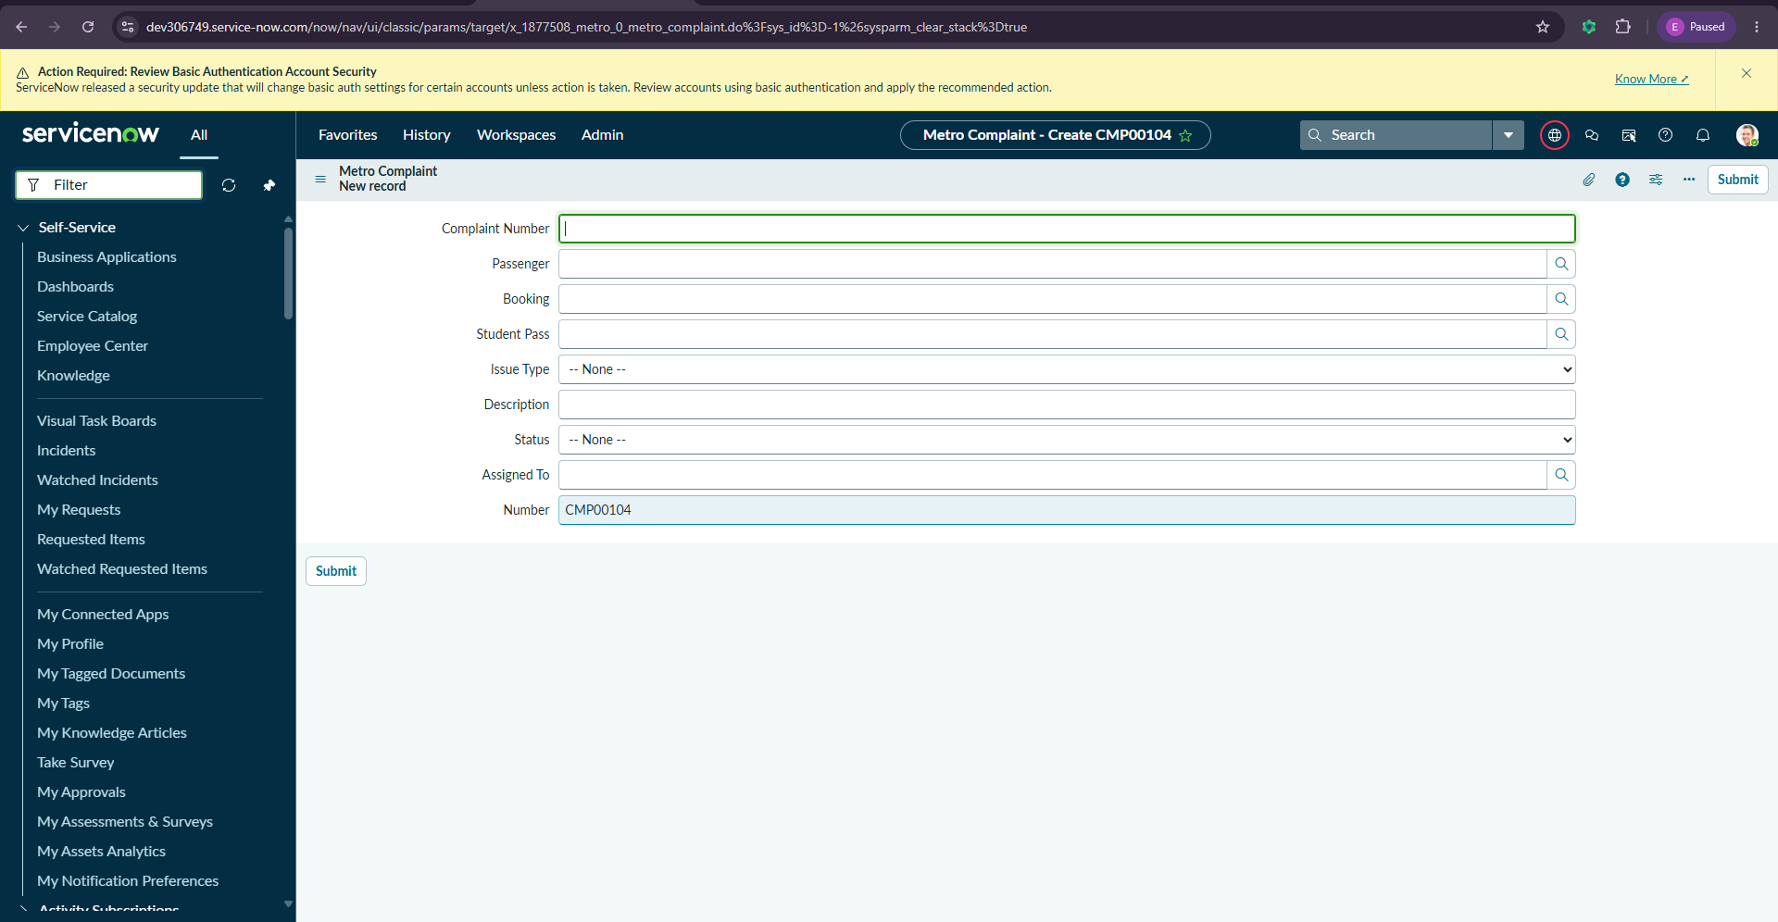
Metro Complaint :
Field Label | Data Type | Description
Complaint Number | Auto Number | Complaint identifier
Passenger | Reference → Passenger | Complaint creator
Booking | Reference → Booking | Related booking
Student Pass | Reference → Student Pass | Related pass
Issue Type | Choice | Ticket / Payment / Pass
Description | String | Complaint details
Status | Choice | Open / In Progress / Resolved
Assigned To | Reference → User | Support agent



5.3 Business Rule Development
Business Rule | Purpose
Auto Link Student User | Links student profile to user record
Auto Generate Route Code | Creates route code automatically
Auto Link Passenger User | Links passenger to user
Auto Booking Number and Fare | Generates booking number and fare
Auto Generate Station Code | Generates station code
Auto Payment ID and Amount | Generates payment details
Auto Student Pass Number and Fare | Generates pass number and fare
Auto Calculate Fare Matrix | Calculates fare matrix values
Prevent Duplicate Active Student Pass | Prevents duplicate active passes
Validate Booking Values | Validates booking information
Set Verified Details | Updates verification fields
Calculate Student Pass Amount | Calculates pass amount
Calculate Booking Fare | Calculates booking fare
Metro Complaint BR | Complaint automation
Metro Student Pass BR | Student pass automation
Metro Student Profile BR | Profile automation
Metro QR Ticket BR | QR ticket automation
Metro Booking BR | Booking automation

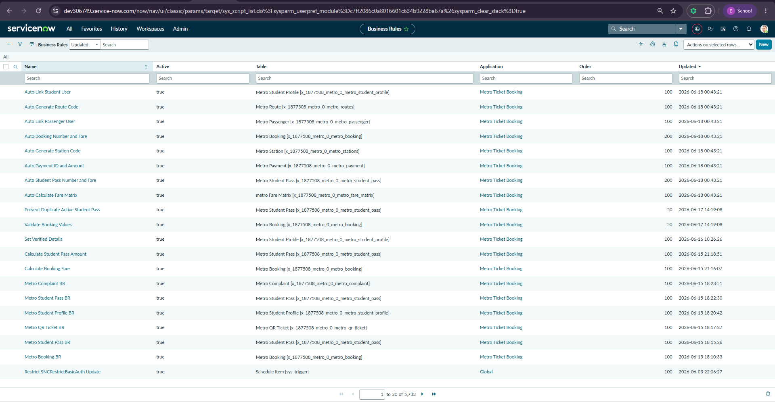

5.4 Script Include Development
Script Include | Purpose
MetroFareCalculator | Calculates booking fare and pass fare amounts
Functions:
• Fare Calculation
• Student Pass Amount Calculation
• Route-Based Fare Processing
• Reusable Backend Logic
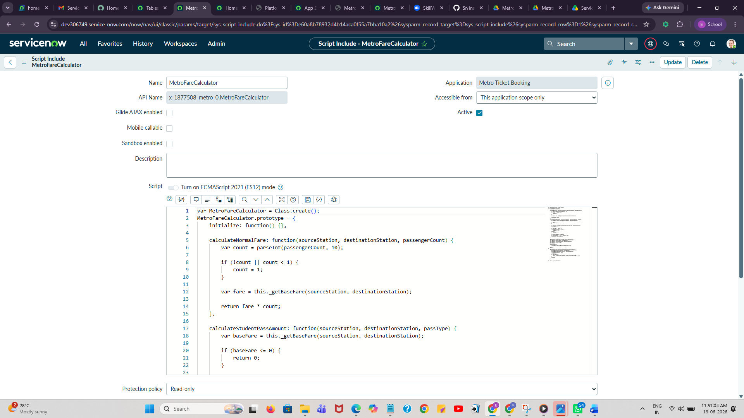

5.5 Flow Designer Development
Flows Implemented:
1. Booking Payment Success :
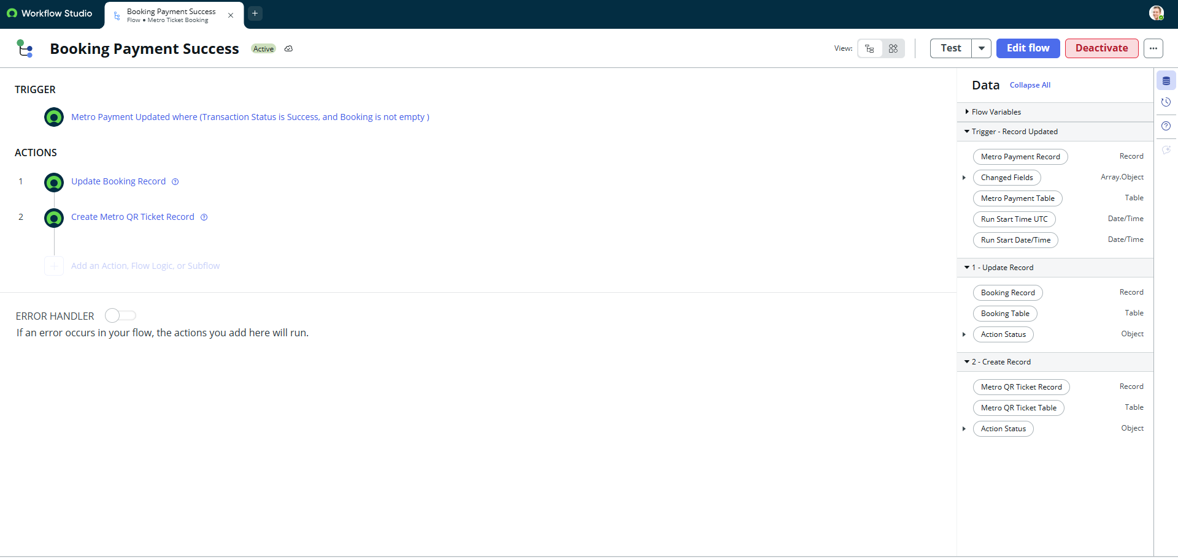
2. Student Pass Payment Success :
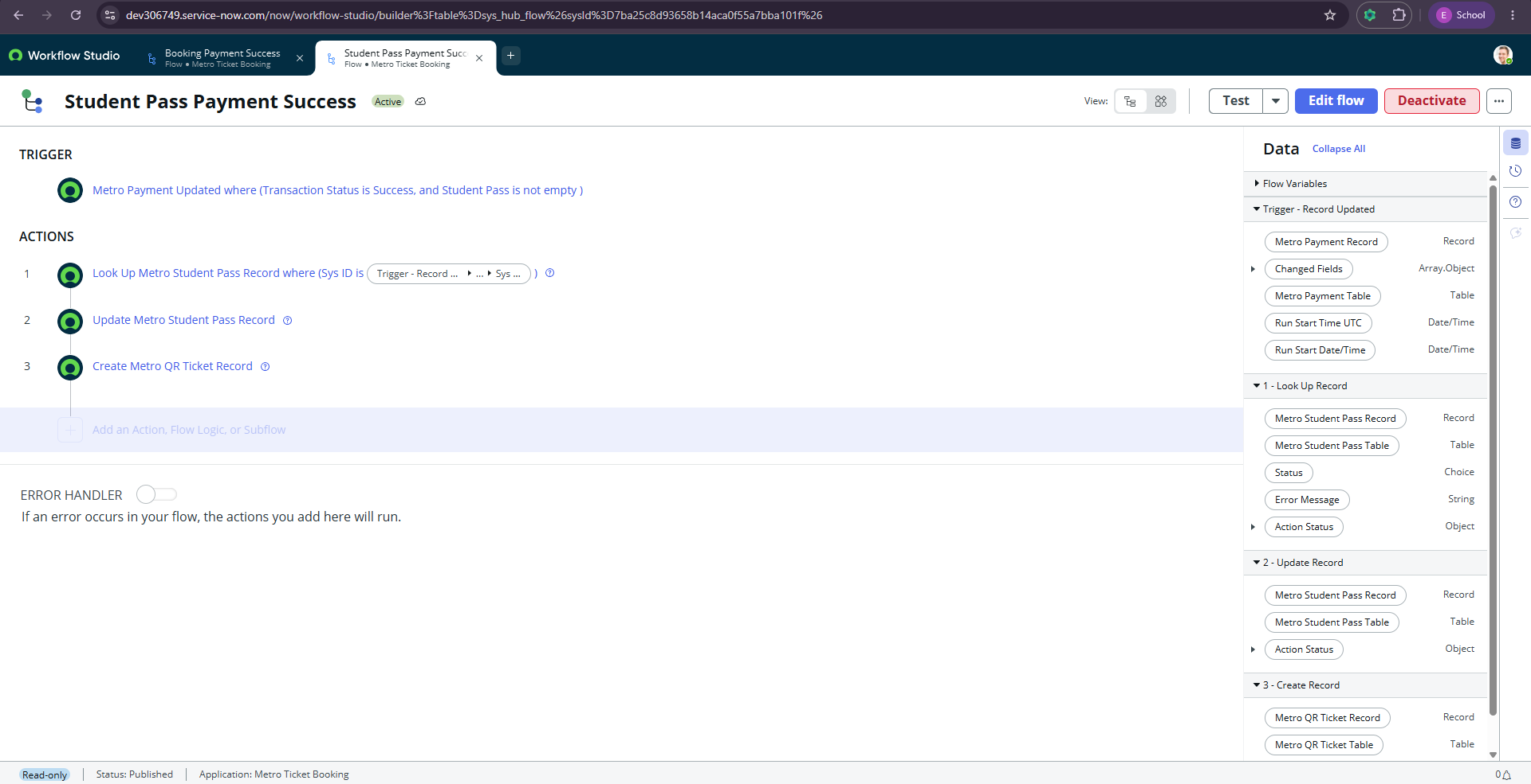

3. Pass Expiry Automation :
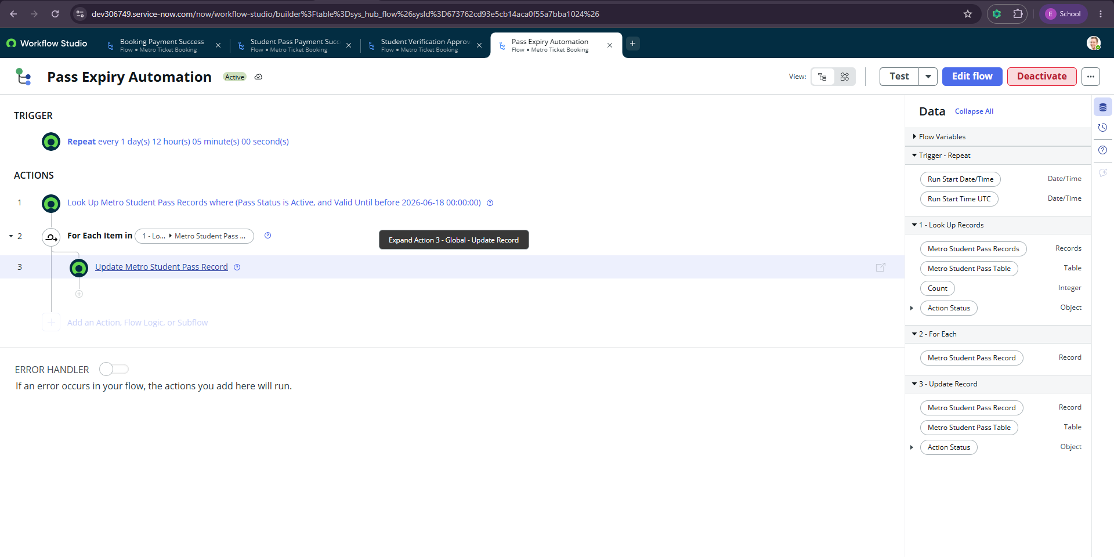

5.6 Flow Diagram
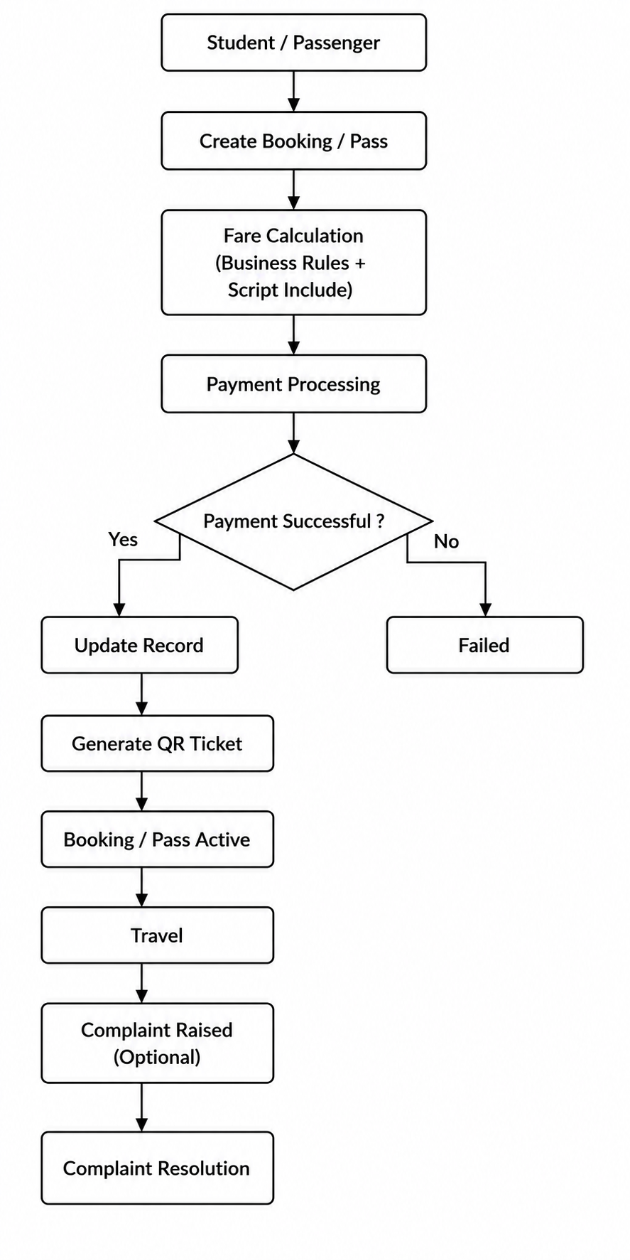

5.7 Service Portal Development
Portal Pages:
• Home Page
• Booking Page
• Student Pass Page
• Complaint Page
• My Tickets Page
• Dashboard Page

